Measurement Uncertainty
# Source: AI Source: Provided by: [Data Path: Persons Table -> ID Column: 1, Name_En Column: Motasem Essam] -> From: [ChatGPT] on [7/17/2026]
Measurement Uncertainty is the estimated range of values within which the true value of a measured quantity is expected to lie. Because no measurement can determine the exact true value with complete certainty, every measurement includes some degree of uncertainty.
Measurement uncertainty is a fundamental concept in science, engineering, metrology, manufacturing, medicine, laboratory testing, and quality control. It provides a quantitative indication of the confidence in a measurement result.

Definition
# Source: AI Source: Provided by: [Data Path: Persons Table -> ID Column: 1, Name_En Column: Motasem Essam] -> From: [ChatGPT] on [7/17/2026]
Measurement Uncertainty is the parameter associated with a measurement result that characterizes the dispersion of values that could reasonably be attributed to the quantity being measured.
In simpler terms:
Measurement uncertainty is the estimated interval around a measured value within which the true value is expected to lie with a specified level of confidence.

Purpose
# Source: AI Source: Provided by: [Data Path: Persons Table -> ID Column: 1, Name_En Column: Motasem Essam] -> From: [ChatGPT] on [7/17/2026]
Measurement uncertainty is used to:
- Express confidence in measurement results.
- Quantify the reliability of measurements.
- Compare measurement results.
- Support scientific research.
- Verify compliance with specifications.
- Improve quality control.
- Assist in decision-making.

Why Measurement Uncertainty Exists
# Source: AI Source: Provided by: [Data Path: Persons Table -> ID Column: 1, Name_En Column: Motasem Essam] -> From: [ChatGPT] on [7/17/2026]
Every measurement is affected by factors such as:
- Instrument limitations.
- Instrument calibration.
- Environmental conditions.
- Measurement method.
- Operator technique.
- Random variations.
- Resolution of the measuring instrument.
Therefore, no measurement is perfectly exact.

Expression of Measurement Results
# Source: AI Source: Provided by: [Data Path: Persons Table -> ID Column: 1, Name_En Column: Motasem Essam] -> From: [ChatGPT] on [7/17/2026]
Measurement results are commonly reported as:
$$\boxed{\text{Measured Value}±\text{Measurement Uncertainty}}$$
Example:
$$25.00±0.05\text{ cm}$$
This means the true value is expected to lie between:
- 24.95 cm
- 25.05 cm
for the stated level of confidence.

Example
# Source: AI Source: Provided by: [Data Path: Persons Table -> ID Column: 1, Name_En Column: Motasem Essam] -> From: [ChatGPT] on [7/17/2026]
Measured length:
$$100.20±0.10\text{ cm}$$
Possible true value:
$$100.10\text{ cm}≤\text{True Value}≤100.30\text{ cm}$$

Sources of Measurement Uncertainty
# Source: AI Source: Provided by: [Data Path: Persons Table -> ID Column: 1, Name_En Column: Motasem Essam] -> From: [ChatGPT] on [7/17/2026]
Measurement uncertainty may arise from:
Instrument Uncertainty
- Limited resolution.
- Calibration uncertainty.
- Instrument drift.
- Mechanical wear.

Environmental Uncertainty
- Temperature.
- Humidity.
- Air pressure.
- Vibration.
- Electromagnetic interference.

Observation Uncertainty
- Reading scales.
- Human reaction time.
- Parallax effects.

Method Uncertainty
- Experimental procedure.
- Mathematical models.
- Sampling methods.

Material Uncertainty
- Variability in the measured object.
- Surface irregularities.
- Material properties.

Types of Measurement Uncertainty

Type A Uncertainty
# Source: AI Source: Provided by: [Data Path: Persons Table -> ID Column: 1, Name_En Column: Motasem Essam] -> From: [ChatGPT] on [7/17/2026]
Estimated using statistical analysis of repeated measurements.
Examples:
- Mean
- Standard deviation
- Variance

Type B Uncertainty
# Source: AI Source: Provided by: [Data Path: Persons Table -> ID Column: 1, Name_En Column: Motasem Essam] -> From: [ChatGPT] on [7/17/2026]
Estimated using information other than repeated measurements.
Examples:
- Calibration certificates.
- Manufacturer specifications.
- Previous measurement data.
- Engineering experience.
- Reference handbooks.

Standard Uncertainty
# Source: AI Source: Provided by: [Data Path: Persons Table -> ID Column: 1, Name_En Column: Motasem Essam] -> From: [ChatGPT] on [7/17/2026]
Standard uncertainty is the uncertainty expressed as a standard deviation.
It is usually denoted by:
$$u$$

Combined Standard Uncertainty
# Source: AI Source: Provided by: [Data Path: Persons Table -> ID Column: 1, Name_En Column: Motasem Essam] -> From: [ChatGPT] on [7/17/2026]
When multiple uncertainty sources exist, they are combined to produce the combined standard uncertainty.
Symbol:
$$u_{c}$$

Expanded Uncertainty
# Source: AI Source: Provided by: [Data Path: Persons Table -> ID Column: 1, Name_En Column: Motasem Essam] -> From: [ChatGPT] on [7/17/2026]
Expanded uncertainty provides an interval with a specified confidence level.
It is calculated as:
$$U=ku_{c}$$
where:
- $U$= expanded uncertainty
- $u_{c}$= combined standard uncertainty
- $k$= coverage factor
A common choice is:
- $k=2$, which corresponds to approximately 95% confidence for many measurement situations.

Confidence Level
# Source: AI Source: Provided by: [Data Path: Persons Table -> ID Column: 1, Name_En Column: Motasem Essam] -> From: [ChatGPT] on [7/17/2026]
Measurement uncertainty is often associated with a confidence level.
Examples:
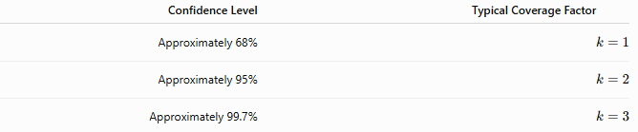
Confidence Level | Typical Coverage Factor
Approximately 68% | $$k=1$$
Approximately 95% | $$k=2$$
Approximately 99.7% | $$k=3$$

Reducing Measurement Uncertainty
# Source: AI Source: Provided by: [Data Path: Persons Table -> ID Column: 1, Name_En Column: Motasem Essam] -> From: [ChatGPT] on [7/17/2026]
Measurement uncertainty can be reduced by:
- Using higher-quality instruments.
- Regular calibration.
- Increasing instrument resolution.
- Taking repeated measurements.
- Improving measurement procedures.
- Controlling environmental conditions.
- Training operators.
Although it can be reduced, measurement uncertainty can never be completely eliminated.

Applications
# Source: AI Source: Provided by: [Data Path: Persons Table -> ID Column: 1, Name_En Column: Motasem Essam] -> From: [ChatGPT] on [7/17/2026]
Measurement uncertainty is essential in:
- Physics
- Chemistry
- Engineering
- Manufacturing
- Medicine
- Metrology
- Calibration laboratories
- Surveying
- Scientific research
- Quality assurance

Everyday Examples
# Source: AI Source: Provided by: [Data Path: Persons Table -> ID Column: 1, Name_En Column: Motasem Essam] -> From: [ChatGPT] on [7/17/2026]
Examples include:
- Measuring body temperature.
- Weighing food.
- Fuel quantity measurement.
- Laboratory chemical analysis.
- Blood pressure measurement.
- GPS positioning.

Common Mistakes
# Source: AI Source: Provided by: [Data Path: Persons Table -> ID Column: 1, Name_En Column: Motasem Essam] -> From: [ChatGPT] on [7/17/2026]
- Confusing uncertainty with measurement error.
- Assuming uncertainty means a measurement is incorrect.
- Ignoring uncertainty when comparing measurements.
- Reporting measurements without uncertainty.
- Assuming repeated measurements eliminate uncertainty.

Measurement Uncertainty vs. Measurement Error
# Source: AI Source: Provided by: [Data Path: Persons Table -> ID Column: 1, Name_En Column: Motasem Essam] -> From: [ChatGPT] on [7/17/2026]
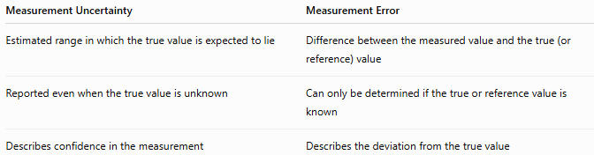
Measurement Uncertainty | Measurement Error
Estimated range in which the true value is expected to lie | Difference between the measured value and the true (or reference) value
Reported even when the true value is unknown | Can only be determined if the true or reference value is known
Describes confidence in the measurement | Describes the deviation from the true value

Measurement Uncertainty vs. Accuracy
# Source: AI Source: Provided by: [Data Path: Persons Table -> ID Column: 1, Name_En Column: Motasem Essam] -> From: [ChatGPT] on [7/17/2026]
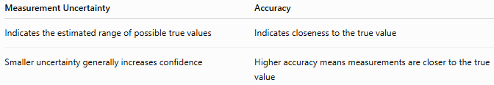
Measurement Uncertainty | Accuracy
Indicates the estimated range of possible true values | Indicates closeness to the true value
Smaller uncertainty generally increases confidence | Higher accuracy means measurements are closer to the true value

Measurement Uncertainty vs. Precision
# Source: AI Source: Provided by: [Data Path: Persons Table -> ID Column: 1, Name_En Column: Motasem Essam] -> From: [ChatGPT] on [7/17/2026]
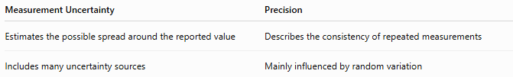
Measurement Uncertainty | Precision
Estimates the possible spread around the reported value | Describes the consistency of repeated measurements
Includes many uncertainty sources | Mainly influenced by random variation

Importance
# Source: AI Source: Provided by: [Data Path: Persons Table -> ID Column: 1, Name_En Column: Motasem Essam] -> From: [ChatGPT] on [7/17/2026]
Measurement uncertainty:
- Improves scientific reliability.
- Supports international measurement standards.
- Enables comparison of measurement results.
- Assists quality assurance.
- Supports engineering decisions.
- Ensures confidence in laboratory results.

Key Points
# Source: AI Source: Provided by: [Data Path: Persons Table -> ID Column: 1, Name_En Column: Motasem Essam] -> From: [ChatGPT] on [7/17/2026]
- Every measurement has measurement uncertainty.
- Measurement uncertainty is not a mistake or an error.
- It represents the estimated range within which the true value is expected to lie.
- It arises from many sources, including instruments, environment, methods, and observers.
- It is commonly reported as Measured Value ± Uncertainty.
- Measurement uncertainty can be reduced but never completely eliminated.

Conclusion
# Source: AI Source: Provided by: [Data Path: Persons Table -> ID Column: 1, Name_En Column: Motasem Essam] -> From: [ChatGPT] on [7/17/2026]
Measurement Uncertainty is the estimated range of values within which the true value of a measured quantity is expected to lie, for a stated level of confidence. It reflects the inherent limitations of every measurement and arises from sources such as instrument characteristics, calibration, environmental conditions, measurement methods, and observer effects. Unlike measurement error, which is the difference between a measured value and the true or reference value, uncertainty expresses the confidence in a measurement result even when the true value is unknown. Reporting measurement uncertainty is an essential practice in science, engineering, manufacturing, medicine, and metrology because it provides a clear indication of the reliability and quality of measurement results.

